|  |  |
| --- | --- |
| **Name:-** Aryan Dilipbhai Langhanoja | **Roll Number:-** 92200133030 |
| **Subject Name and Code:-**Foundation Skills in Sensor Interfacing (01CT1103) | **Date of Experiment:-** 11-11-2022 |

|  |  |
| --- | --- |
| Task:- |  |

Interface potentiometer with Arduino Uno and control the brightness of LED

|  |  |
| --- | --- |
| Components:- |  |

* Arduino UNO R3
* Potentiometer
* LED
* Jumper Wires
* Resistor
* Bread Board
* Laptop Or PC

|  |  |
| --- | --- |
| About the Project:- |  |

* Here, we will measure the amount of resistance as an analog value produced by the potentiometer. We will connect the potentiometer to will measure the state of potentiometer.

|  |  |
| --- | --- |
| Schematic: |  |

* In This Project, We will control The Brightness of LED by the potentiometer. First we will connect the one terminal of potentiometer with 5V and other in GND. And the wiper is connected with analog pin 4.After that we will connect the anode of LED in Digital pin 11 and cathode is connected with resistance and resistance is connected wit GND.

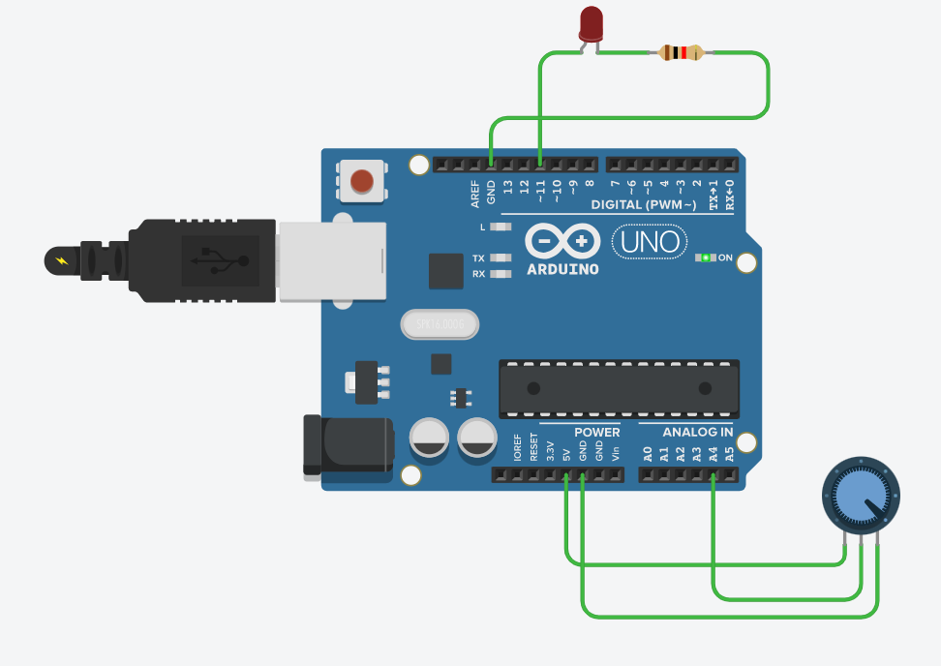

|  |  |
| --- | --- |
| Output:- (your circuit implementation and its working photo) |  |

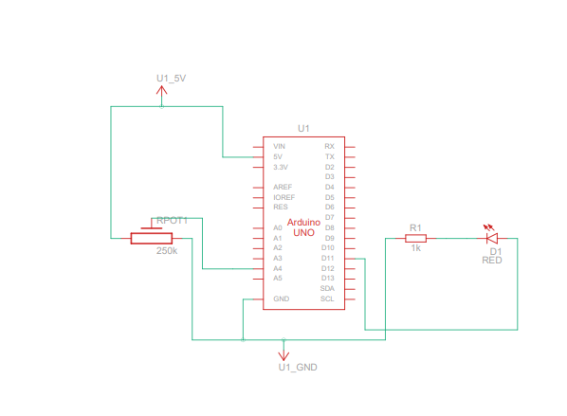

|  |  |
| --- | --- |
| Code:- |  |

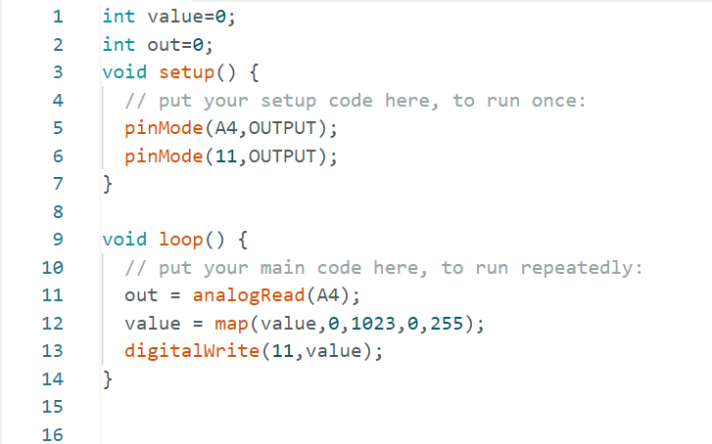

|  |  |
| --- | --- |
| Application:- |  |

* One outer pin of the potentiometer is connected to ground (GND), and other external pin is connected to 5V of the Arduino board. The middle pin of the potentiometer is connected to the analog input pin A4 of the board. The positive terminal of the LED is connected to pin number 13 of the board, and the negative terminal is connected to the GND with resistor.

|  |  |
| --- | --- |
| Conclusion:- |  |

* In this Task, We learnt how to use potentiometer and how to control brightness of LED.